Building Blocks: Green-Red
Zvi Mowshowitz
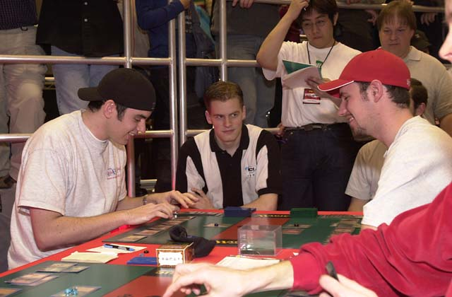
Benafel and Fuller play each other in the quarterfinals
While it failed to win or finish second, the deck of Tokyo was clearly R/G, in particular the version used by AlphaBetaUnlimited.com. It managed to place four people into the Top 8 along with 15th and 17th places, which was an amazing result. The deck wasn't amazing, it didn't have any technology that was too suprising. Everyone was expecting it. So how did it do so well? It's probably best to start with the core of the deck.
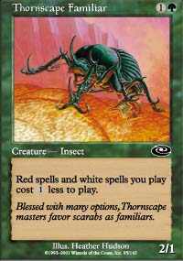
It's pretty clear that all R/G decks in Invasion Block should have four copies each of Thornscape Familiar and Kavu Titan as the most efficient two drops. After that, the deck needs one more second turn play to consistently apply early pressure. The only two real choices are Blurred Mongoose and Yavimaya Barbarian, and the Mongoose wins that battle pretty easily. It's better in the mirror, better even against most blue decks due to being uncounterable and untargetable. Even against The Solution, the Barbarian is red. Just about the only problem with it is that it trades with Ravenous Rats and gets killed by Nightscape Familiar. With Raging Kavu in the deck (I'll get to why in a second), there are already enough one toughness creatures to make Ravenous Rats trade off almost all the time and to make Familiar a troublesome blocker, and adding one more doesn't change things much.
Ryan Fuller
R/G - PT Tokyo 2001
Main Deck |  | Sideboard
10 Forest  1 Keldon Necropolis  9 Mountain  4 Shivan Oasis  4 Blurred Mongoose  2 Flametongue Kavu  4 Kavu Titan  4 Raging Kavu  4 Skizzik  4 Thornscape Battlemage  4 Thornscape Familiar  2 Yavimaya Barbarian | 4 Ghitu Fire  4 Urza's Rage | 2 Flametongue Kavu  3 Gaea's Herald  2 Jade Leech  3 Overabundance  4 Thunderscape Battlemage  1 Wallop

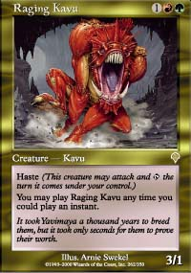
The next question is how to get haste. Fires of Yavimaya is still around, but without the fading creatures and Saproling Burst that make it so good in Standard. Instead it can only be used as it was meant to be used. Its use must be weighed against the desire to play creatures that have haste naturally. Raging Kavu and Skizzik are better creatures than the alternatives, and Kavu Runner works extremely well with Thornscape Familiar. Together, playing these creatures is more important than playing Fires of Yavimaya. Again, the results from Tokyo can be used to confirm this result. If Fires belonged in the deck, people would have done reasonably with versions containing it, and they did not.
Raging Kavu is good enough to include four copies of almost automatically, and clearly the deck should include at least three Skizziks. The next two categories of cards are the burn spells and the creatures that kill other creatures when they come into play. Urza's Rage and Ghitu Fire are the logical burn spells for the deck, although Assault and Battery can't be outright dismissed. The problem with Assault and Battery is that on turn one there is nothing to Assault, because everything in all the major decks costs at least two. Without that potential time gain, being unable to kill a Skizzik is crippling enough to keep it out of the deck. Urza's Rage and Ghitu Fire also work very well with Overabundance, which is in this deck's sideboard most of the time. Lucas Hager only used three Ghitu Fire, but I think that was a slight error and the deck should probably contain four.
Chris Benafel
R/G - PT Tokyo 2001
Main Deck |  | Sideboard
9 Forest  2 Keldon Necropolis  9 Mountain  4 Shivan Oasis  4 Blurred Mongoose  2 Flametongue Kavu  2 Kavu Runner  4 Kavu Titan  4 Raging Kavu  4 Skizzik  4 Thornscape Battlemage  4 Thornscape Familiar | 4 Ghitu Fire  4 Urza's Rage | 2 Flametongue Kavu  3 Jade Leech  2 Kavu Runner  4 Overabundance  4 Tranquility

The next issue is Flametonge Kavu and Thornscape Battlemage. Flametonge Kavu is risky because if there's nothing to kill it will blow up itself or something else on the same side, so it's not an automatic four. Thornscape Battlemage, on the other hand, is. The normal hedge was to put two Flametonges in the board and two in the maindeck, which is a solid choice. Totaling up the deck, that makes 33 non-land cards. Instinct says this deck runs 24 lands and that's what three out of four of them did (Hager had 25), so that leaves three extra slots. Freneau filled them with three Kavu Runner. Ryan Fuller used Barbarians, but he did that on the basis of an incorrect metagame call so it can be discounted. Benefal chose to use the fourth Skizzik and two Kavu Runner in the last three slots, and this seems to me like the logical way to fill out the deck. After that, all that remains in the maindeck is to choose the lands, which comes down to a decision on whether to run the second Necropolis or not. That decision can go either way.
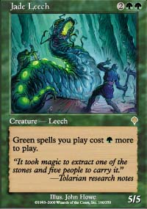
For the sideboard, the key cards are Jade Leech for the mirror, Flametonge Kavu for creature decks and Overabundance for control. Kavu Chameleon is an alternative anti-control card and much better against The Solution but rather slow for its intended job. The rest of the sideboard ended up going to tuning slots or to Tranquility or Thunderscape Battlemage, which were defense against possible Domain decks. Ryan made some odd sideboarding choices, but they proved not to be worthwhile. The most notable missing sideboard card would probably be Shivan Wurm.
All of that is pretty straightforward, a solid assembly of an obvious and expected deck. That leads to the big question. What did AlphaBetaUnlimited do so much better than everyone else? I asked Freneau and he said basically "second turn Familiar, third turn Kavu Runner, fourth turn Skizzik." It's hard to believe that's all it was, because Fuller didn't even have any Runners and the others had varying numbers of them. After an extensive check of the other decklists, the answer appears to be very simple. With very few exceptions, the other R/G players made a critical mistake in deck construction, and it added up over fourteen rounds. The biggest mistake was playing Overabundance in the maindeck, which was an incorrect metagame call. In a different field it makes sense, in this one full of B/R and R/G it was deadly.
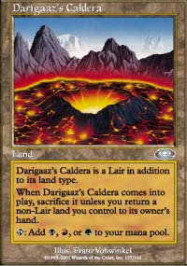
The second big mistake was another metagame question, this one a case of paranoia. A lot of players used Thunderscape Battlemage in the maindeck to fight potential Domain decks, and often even backed that up with more removal in the sideboard. When Domain failed to make a good showing, this proved an expensive hedge. A related issue was the use of Darigaaz's Caldera, which allowed them to use the black kicker but was brutal to their mana base. After that, the biggest error was in sideboarding where many players didn't sideboard in Jade Leech. An argument can be made for Shivan Wurm, or for both Leech and Wurm, or for maindecking Jade Leech, but to have no access to additional 5/5s or 7/7s is very poor in the mirror matchup. There are a few decklists that have Yavimaya Barbarian instead of Blurred Mongoose but are otherwise very very close, and it's hard to tell if they're independent versions or from within the team.
In the end, the success of AlphaBetaUnlimited speaks volumes about Block Constructed. They got the deck right (or almost right), almost everyone else got it wrong by about four cards out of sixty, and they took that advantage and dominated the tournament. Good preparation has always been the key to Block Constructed, and this time was no different. A majority of those who played the good version of Red/Green placed 17th or higher, and if the non-Mongoose versions come from within the team and are discarded, that rises to Top 8. If they don't come from within the team that just makes it even clearer how important small changes are. This wasn't an all-Pro team either, although it did have on it Benefal, Fuller and Cornelissen.
Phillip Freneau
R/G - PT Tokyo 2001
Main Deck |  | Sideboard
9 Forest  2 Keldon Necropolis  9 Mountain  4 Shivan Oasis  4 Blurred Mongoose  2 Flametongue Kavu  3 Kavu Runner  4 Kavu Titan  4 Raging Kavu  3 Skizzik  4 Thornscape Battlemage  4 Thornscape Familiar | 4 Ghitu Fire  4 Urza's Rage | 2 Flametongue Kavu  3 Hull Breach  4 Jade Leech  4 Kavu Chameleon  1 Kavu Runner  1 Skizzik

The practical question of course is how this applies to future Invasion Block tournaments. If early hints are any indication, Apocalypse is going to blow all the Tokyo decks out of the water, but until then this build has to be considered the deck to beat. It wouldn't be suprising to have as many as a third of early tournaments be practically identical. The deck is easy to find, easy to assemble, relatively easy to play and works very well. I won't go into how to play it because I don't think it's necessary.
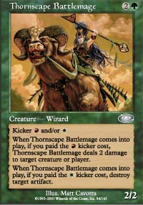
From the opposite end of the table, the R/G deck is an explosive and aggressive deck. It can be divided into three parts. The first is the creatures. The deck can be expected to pump out a creature every turn starting on turn two for a while - if it doesn't, it had a bad draw. Then there's the burn. In practical terms, the burn together with Flametonge Kavu and Thornscape Battlemage means the deck has a good deal of removal and can burn out players who stray into the single digits. So where does that leave a deck that is trying to beat R/G?
First, the deck must be fast. If cards don't start flying on turn two there's going to be trouble, and if they don't come out turn three it's likely to all be over unless there are some really big guns coming out. Fundamentally, R/G is too fast to beat on speed, so the goal of any deck trying to beat R/G must be to either trade off favorably or nullify its strategy, or some mixture of the two. For trading off, the basic problem is just making up for the deck's eight free removal spells. After that another deck can start to gain an advantage. B/R decks can start out with their own Flametonge Kavus, and use Ravenous Rats to trade off for the one toughness creatures. At that point, it comes down to fitting in more card advantage cards like Blazing Specter, Bog Down and Crypt Angel or trying to gain advantage through having bigger creatures and using Terminate to take down R/G's big ones. In the end of course, there's Pyre Zombie, so if B/R can stay alive for long enough it will win.
Lucas Hager
R/G - PT Tokyo 2001
Main Deck |  | Sideboard
10 Forest  1 Keldon Necropolis  10 Mountain  4 Shivan Oasis  4 Blurred Mongoose  2 Flametongue Kavu  4 Kavu Runner  4 Kavu Titan  4 Raging Kavu  3 Skizzik  3 Thornscape Battlemage  4 Thornscape Familiar | 3 Ghitu Fire  4 Urza's Rage | 2 Flametongue Kavu  4 Jade Leech  3 Kavu Chameleon  4 Overabundance  1 Skizzik  1 Thornscape Battlemage

B/U tries to do more or less the same thing, and Fujita was eating R/G decks alive during the tournament. His deck used Addle and Prohibit and Ravenous Rats, ensuring that he would not fall behind R/G if both decks got normal draws. With Yawgmoth's Agenda and Fact or Fiction, he had an automatic grip on the long game if things were stable. Again, the basis is quick trading backed up by card advantage. B/R/U decks didn't have as many cheap answers but had access to better removal if they lasted. The Solution (the W/U deck I used to win the tournament) combines quick trading off of its own fast creatures with Exclude and Fact or Fiction for card advantage and Crimson Acolyte and Meddling Mage to nullify the opponent's strategy. Both decks have the same amount of land and everything in the W/U deck at least trades off, so given time Exclude, Meddling Mage, Crimson Acolyte and Fact or Fiction will combine to overwhelm the R/G deck while Apprentice and counters keep the big green threats if any from attacking. The only danger there is Keldon Necropolis. Finally, there are Domain decks, which try to nullify the whole deck using Collective Restraint or trade off with it using more powerful cards if the R/G has too much removal. These decks didn't work out in Tokyo, although it's possible they could be made to work. Overall, R/G is definitely a beatable deck in a number of ways, but should still be the biggest factor early on. If it adjusts, it will probably adjust to deal with W/U decks and to be better in the mirror.

